ABSTRACT
Choosing a right course in formative years is very important decision as his future depends on this one decision. Student by himself is not mature enough to take right decision in his early life. Selecting wrong courses means mismatch between student aptitude, capability and personal interest. Faculty or parents have neither the required knowledge nor experience. Since there is no other reliable source generally available that can guide the student towards the most suitable direction, recommender system has been evolved to provide him guidance in selecting a right course. Recommender system is a computer programme prepared with the help of experts where the details of background of the students and their aptitudes help finding a course for his future study.
In this project, I present an applied research on designing and developing a recommender system for undergraduate admission seekers into the Lagos State polytechnics which can help them to choose the right courses matching some of their specific academic profile. Here I have developed a technique to transform collected data of students' for all types of relevant information into a universal database format using academic data of successful students who have already got opportunity to study in the school. After that I have developed an algorithm for admission predictor and course recommender system which can calculate similarity between training and test data set based on weighted scores using mean squared deviation similarity metrics. Clustering technique is used to find structures and relationship within the data. K-nearest Neighbor algorithm for calculating top N similar users for the test users and recommend best K courses to users from N similar users. This project also reveals the research process of preparation of such a recommender system.

CHAPTER ONE
1.1 INTRODUCTION
Higher education systems all over the world nowadays are challenged by the new information and communication technologies.(Boufardea and Garofalakis, 2012). With the increasing competition among higher education institutes, most are focusing on how to increase student retention rates and number of completions. University performance is one of the means of measuring its quality and reputation (Jusoff et al,2008); thus higher education institutions are becoming more interested in predicting the paths of students, and identifying which students will require assistance in order to graduate. (Luan, 2004) Higher learning institutions encounter many problems which keep them away from achieving this objective. Some of these problems stem from knowledge gap. Knowledge gap is the lack of significant knowledge at the educational main processes such as counseling, planning, registration, evaluation and marketing. For instance, many learning institutions do not have access to the necessary information to counsel students, thus they are unable to give suitable recommendation to the students. Also, there is a growing interest and concern in many countries about the problem of school failure and the determination of its main contributing factors.
This problem has been referred to as ―the one hundred factors problem‖.(Ventura and Romero, 2011). Studies have shown that not all students who enroll as freshmen will complete their studies. (Bean,2005). The study of factors that influence the academic performance of students in higher education has a long history. The philosophy behind these studies is to understand what is related to, or predicts, poor academic performance and to use this information to design appropriate interventions (McKenzie &Schweitzer, 2001). A plethora of factors have been found to predict or influence retention and performance, falling into a number of broad categories: including gender, personality factors, intelligence and aptitude tests, academic achievement, previous college achievements, and demographic data, student background and demographics, prior educational achievement and level, psychosocial factors and approaches to study, and institutional and course factors (Scott & Smart, 2005; Wimshurst & Allard, 2008). However, factors found to be predictive in some studies are not always predictive in others (DeBerard, Spielmans & Julka, 2004), due in part to the ways in which different studies are designed. Indeed, even in the same study with the same methodology, results for student cohorts sampled at different universities have differed (Vandamme, Meskens & Superby, 2007) and in general the results of particular studies cannot be generalised to other environments (Scott & Smart, 2005). Machine learning is considered the most suitable technology in giving additional insight into educational entities such as; student, lecturer, staff, alumni and managerial behavior. It acts as an active automated assistant in helping them make better decisions on their educational activities. So far, there are limited numbers of research that examine the influence of family factors on first year academic performance in tertiary institution. In this work, focus is on how to design a predictive framework to serve as a basis for predicting the performance of students at the end of their first year in tertiary institution based on their family background factors and previous academic achievements using machine learning algorithms.
1.1.2 Recommendation Systems in Machine Learning
Recommender systems are the systems that are designed to recommend things to the user based on many different factors. These systems predict the most likely product that the users are most likely to purchase and are of interest to. Companies like Netflix, Amazon, etc. use recommender systems to help their users to identify the correct product or movies for them.
The recommender system deals with a large volume of information present by filtering the most important information based on the data provided by a user and other factors that take care of the user’s preference and interest. It finds out the match between user and item and imputes the similarities between users and items for recommendation.
Both the users and the services provided have benefited from these kinds of systems. The quality and decision-making process has also improved through these kinds of systems.

1.2 STATEMENT OF THE PROBLEM
The problems facing students admission system are on the shortcomings of having a reliable record of students admission into specific departments based on previous statistics; However, the traditional means that has lingered over time has been considered upgradable. Below are some of the itemized problems:
i. inability to gather accurate dataset from the students that has applied.
ii. The challenge of processing through the statistical records and concluding accurately.
iii. Time factor in attempting the prediction process
iv. Cost of affording papers and documenting records.
1.3 AIM AND OBJECTIVES OF THE STUDY
AIM
To develop a recommender system that will guide students on the various choice of study in the Lagos State Polytechnic
OBJECTIVES
In order to encounter the problems, a systematically review is proposed. The proposed systematically review is to support the objectives of this study, which are:
- To determine if a student can be admitted to his/her department of choice
- To suggest other departments that can admit a student if he/she can’t secure admission into his/her preferred department.
1.4 SCOPE OF THE STUDY
The intelligence recommendation system will be developed as a machine learning application that can predict if a student will be able to get admission into the department of their choice and also suggest to them which department they are likely to get admitted into. Using some set of tools to achieve it:
i. Machine learning tool,
ii. recommendation algorithm
iii. Python programming language
1.5 RESEARCH METHODOLOGY
The main aim of the system is to predict the admission possibilities of the student into certain departments using certain data of the student such as number of credits in olevel result, jamb score, post jamb score, number of sittings for olevel result etc. After predicting the student admission, the system will also compare the results generated by more than two classification algorithms and there after determine which of them is more accurate and efficient. The data to be provided as the input must have the values of the attributes classified into specific variables. The dataset is collected by preparing a questionnaire which is to be filled by students of the school who already got admitted, those who have applied but not admitted and those who are about to apply. This is to get various data points in other to gather enough fact for admission requirements from individuals. The data is then processed and can now be used to build the model. Using this normalized data, the system runs for example the Decision Tree algorithm on it and classifies the data. This classified data is then used to predict the admission status of the student.
Research Questions
Right research questions are important to understand the study of admission prediction. And this is the first step of solution to the problem.
How many times did you apply before you were admitted or still denied admission?

What was your jamb score when you got admission or was denied admission?
What was your post jamb score when you got admission or was denied admission?
At least how many credit did you have in WAEC or NECO when you got admission or was denied admission?
how many sittings did you used to apply for admission when it was successful or when it was denied?
What was your age range when you got admission or when you were denied admission?
Which department did you applied to when your admission was successful or when denied admission.

1.6 SIGNIFICANCE OF THE STUDY
This research will have an impact in the following areas:
- Student Admission
ii. Further researches to be carried out using recommendation algorithms.

1.7 LIMITATION OF THE STUDY
The challenges facing the accomplishment of this research are on the following areas:
i. Financial constraints: Lack of enough fund to foster the research like buying of data to carry out further researches.
ii. Limited available research materials: This research is bound to face some setbacks based on the limited resources available in the school and around that has to do with data science and artificial intelligence
iii. Limited time: The amount of time stipulated to carry out this research is quite limited following the complexity of the research
iv. The programming language and it’s complexity: the programming language in use is python and it requires enough carefulness and attention to achieve a good AI program with it.
1.8 DEFINITION OF TERMS
i. Artificial Intelligence: In computer science, artificial intelligence, sometimes called machine intelligence, is intelligence demonstrated by machines, in contrast to the natural intelligence displayed by humans
ii. Data science: Data science is a inter-disciplinary field that uses scientific methods, processes, algorithms and systems to extract knowledge and insights from structured and unstructured data. Data science is related to data mining and big data.
iii. Python: Python is an interpreted, high-level, general-purpose programming language. Created by Guido van Rossum and first released in 1991, Python's design philosophy emphasizes code readability with its notable use of significant whitespace
iv. Prediction:a thing predicted; a forecast.
v. Admission: the process or fact of entering or being allowed to enter a place or organization.
vi. Software: Computer software, or simply software, is a collection of data or computer instructions that tell the computer how to work. This is in contrast to physical hardware, from which the system is built and actually performs the work.
vi. SSC: The Secondary School Certificate, also called SSC or Matriculation examination
vii. HSC : HSC stands for Higher Secondary Certificate, comprising two years from classes XI and XII that leads to the higher secondary exam.

CHAPTER TWO
LITRATURE REVIEW
2.1 INTRODUCTION
To present the research entitled “Intelligence Recommender System for Admission” related available information in general has been reviewed and presented below.
Admissions into Nigerian universities have become a big issue over the years because of the ever increasing demands for University education and the availability of only 75 universities in the country. Prior to 1978 each University conducted its placement examination and admitted its students in line with available spaces. On realizing that very intelligent candidates obtained admissions into a number of Universities but settled for one while denying many of apportunities the Federal Government of Nigeria introduced Central placement examination body. This body known as the Joint Admissions and Matriculation Board (JAMB) was established by Decree No. 2 of 1978 (Nwadiani & Igineweka, 2005).
In order to regulate admissions into the institutions of learning in Nigeria the Federal Government initiated and promoted a federal character policy which gave rise to the concept of equalization of opportunity in university education. The federal character policy implies that public authorities, Semi-government agencies, institutions of learning and even the private sector should ensure fair and effective representation of states or local government areas or ethnic groups in positions of power, authority, placement in enrolment into schools and so on (Adejo, 2005, p. 277). The political Bureau Report (FRN, 1987) refers to the federal character policy as how fair and equal representation can be given to the various component units and communal groups in the country’s institutions of learning, agencies and positions of power, status and influence. Furthermore, the Federal Character Commission (FRN 1996) states that Federal Policy involves lowering the entry and promotional qualifications of states considered to be disadvantaged in educational opportunities. The rationale of this policy, according to Adejo (2005), is that by a proper application of the doctrine of Federal Character, all ethnoregional areas, groups and communities will be given equal opportunity to participate in the Socio-economic and political life of Nigeria. Yoloye (1989) identifies three areas that form parts of the principles of the federal character policy as; number of students admitted; the staff appointment from each state as well as the even spread of Universities across the various geo-political zones of the country. According to Yoloye (1989) these principles are the necessary guide in the application of the Federal Character Policy in all Universities and other educational institutions.
The Problem
Nigeria has a population of about 140 million (Daily Sun, January 15, 2007) with a total of 75 Universities. Table 1 shows a list of some selected countries with their populations and number of Universities. The table shows that Nigeria has the least number of Universities serving a high population when compared to other countries. For examples, Japan with the population of 127 million people has 1,223 Universities, the United States of America (USA) has a population of 290 million people with 5,758 Universities. The observed inadequacy in the number of Universities in Nigeria coupled with the high demand for University education have created the problems of admissions into the available Universities and the sustenance of good standards. An effort to check these problems prompted the Federal Government of Nigeria to establish the Joint Admissions and Matriculation Board (JAMB) in 1978 to handle all admission matters with respect to Universities at the first instance and later other tertiary institutions were included. The JAMB has not been able to solve the admission and quality of education problems. Babalola (2005) and Eluemunor (2005) believe that many unqualified candidates have been offered admissions into Nigerian Universities through JAMB thereby lowering standards in these institutions. The issue of quality in Nigerian Universities is also confirmed as being low by the World Universities Ranking Project for 2005 which placed Nigeria’s best University (the University of Ibadan which ranked 59th in Africa) as 6 ,320th in the world (Daily Sun, November 21, 2005, p. 8).
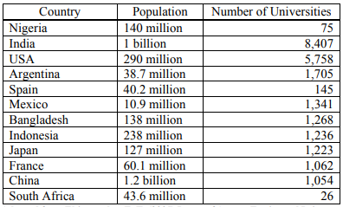
Table 1: Access to University Education in Some Selected Countries
Adapted from Ehiemetalor, E. T. (2005) Issues of Access, Equity and Private Sector participation in the Deregulation of Education, P. 261.
The problems of admissions into Nigerian Universities and the maintenance of adequate standards have been associated with some unpopular policies adopted by the Federal Government of Nigeria to address the inadequacy in the number of admission places in the University system. Among the unpopular policies included:
- Catchment areas policy which provided that a certain percentage of admission places must be reserved for the indigenes of the areas in which universities are located.
(b) Backwardness factor policy ensured that a certain percentage of admission chances was reserved for the indigenes of States considered to be educationally disadvantaged or backward.
(c) Quota system policy provided the allocation of certain percentages of admission places into Nigerian Universities based on populations, ethnic considerations and States of Origin.
(d) Discriminatory fees policy provided for lower fees to be paid by the indigenes of the localities where Universities are established.
Akani (1996) believes that the above policies resulted in the reduction of admission standards and this allowed poorly qualified candidates to be admitted into Nigerian Universities. This is because the policy conferred on the various categories of persons the rights of admission whether qualified or not. Furthermore, Akani (1996) believes that the quality of University education in Nigeria has consequently been lowered as a result of the Federal Government admission policies which apparently de-emphasize quality.
2.2 Equalization of Opportunity and Admission Placement
The practice of the policy of equalization of opportunity covers all aspects of the life of Nigerian people. However, the focus of this study is on the practice of this policy in University education with particular attention to admission and its effect on the University system. Onyeoziri (1989) notes that the principle of equalization which derive from the federal character policy has become most important consideration in admissions, establishment of universities, recruitment and promotion of staff in federal educational institutions. The quota system is the formula used in the equalization of educational opportunity through its influence on admission matters. Onwuka (1991) believes that the quota system which stipulates the number of candidates which should come from each State whether qualified or not is one of the euphemisms that has to be practiced in the equalization process in education. Yoloye (1989) opines that the form of quota system in practice in Nigeria is one borne out of a “reasoned compromise”. According to him this is based on four elements namely: academic merit, educationally disadvantage state, catchment areas, and discretion. Academic merit, according Yoloye (1989), is determined by the scores in the University Matriculation Examination (UME) conducted by the Joint Admission and Matriculation Board (JAMB), WAEC/NECO or London/GCE A – level examination. The policy on educationally disadvantage states” is seen as another euphemism in the application of admission policy under the federal character concept. According to a Federal Government Circular (FME/S/518/VO/01/99 of 2nd September 1983) in Okwori (2003, pp. 55 – 56) educationally disadvantaged States in Nigeria are Bauchi, Benue, Borno, Cross-River, Gongola, Kaduna, Lagos, Niger, Plateau, Rivers and Sokoto. “Catchment Area” is another phrase in the admission policy to promote equalization of educational opportunity. “Catchment area’ refers to the locality in which federal universities are established. This policy stipulates that the states in the immediate vicinity of each University should derive special preferences in terms of admissions. The admission policy of “discretion” opportunity is given to universities to cater for good candidates that would be adversely affected in the process of applying the various quota system guidelines. The most current guideline on admission approved by the Federal government of Nigeria through the National Universities Commission (NUC, 1999) is as follow: Merit = 45%, Catchment area = 35%; disadvantaged states = 20% (NUC 1999, P. 5). In the application of these criteria it is important to note the following proviso by the Federal Government through the NUC (1999, p.68).
- If because of the pattern of applications and the range of courses offered by universities cannot fill all the places allocated to some States, Universities are to consult the second choice lists of candidates.
- In any given university no state shall benefit from both the criteria of locality and educationally disadvantaged.
2. 3 MACHINE LEARNING
Because of new computing technologies, machine learning today is not like machine learning of the past. It was born from pattern recognition and the theory that computers can learn without being programmed to perform specific tasks; researchers interested in artificial intelligence wanted to see if computers could learn from data. The iterative aspect of machine learning is important because as models are exposed to new data, they are able to independently adapt. They learn from previous computations to produce reliable, repeatable decisions and results. It’s a science that’s not new but one that has gained fresh momentum.
Machine learning (ML) is the subset of artificial intelligence (AI) that focuses on building systems that learn or improve performance based on the data they consume. Artificial intelligence is a broad term that refers to systems or machines that mimic human intelligence. Machine learning and AI are often discussed together, and the terms are sometimes used interchangeably, but they don’t mean the same thing. An important distinction is that although all machine learning is AI, not all AI is machine learning.
Today, machine learning is at work all around us. When we interact with banks, shop online, or use social media, machine learning algorithms come into play to make our experience efficient, smooth, and secure. Machine learning and the technology around it are developing rapidly, and we're just beginning to scratch the surface of its capabilities. While many machine learning algorithms have been around for a long time, the ability to automatically apply complex mathematical calculations to big data over and over, faster and faster is a recent development. Here are a few widely publicized examples of machine learning applications you may be familiar with:
- The heavily hyped, self-driving Google car? The essence of machine learning.
- Online recommendation offers such as those from Amazon and Netflix? Machine learning applications for everyday life.
- Knowing what customers are saying about you on Twitter? Machine learning combined with linguistic rule creation.
- Fraud detection? One of the more obvious, important uses in our world today.
Types of Machine Learning: Two approaches to learning
Algorithms are the engines that power machine learning. In general, two major types of machine learning algorithms are used today: supervised learning and unsupervised learning. The difference between them is defined by how each learns about data to make predictions.
2.3.1. Supervised Machine Learning: Supervised machine learning algorithms are the most commonly used. With this model, a data scientist acts as a guide and teaches the algorithm what conclusions it should make. Just as a child learns to identify fruits by memorizing them in a picture book, in supervised learning, the algorithm is trained by a dataset that is already labeled and has a predefined output. Examples of supervised machine learning include algorithms such as linear and logistic regression, multiclass classification, and support vector machines.
2.3.2. Unsupervised Machine Learning : Unsupervised machine learning uses a more independent approach, in which a computer learns to identify complex processes and patterns without a human providing close, constant guidance. Unsupervised machine learning involves training based on data that does not have labels or a specific, defined output. To continue the childhood teaching analogy, unsupervised machine learning is akin to a child learning to identify fruit by observing colors and patterns, rather than memorizing the names with a teacher’s help. The child would look for similarities between images and separate them into groups, assigning each group its own new label. Examples of unsupervised machine learning algorithms include k-means clustering, principal and independent component analysis, and association rules.
2.3.3 Reinforcement Learning: Reinforcement Learning is a feedback-based Machine learning technique in which an agent learns to behave in an environment by performing the actions and seeing the results of actions. For each good action, the agent gets positive feedback, and for each bad action, the agent gets negative feedback or penalty. In Reinforcement Learning, the agent learns automatically using feedbacks without any labeled data, unlike supervised learning. Since there is no labeled data, so the agent is bound to learn by its experience only.
RL solves a specific type of problem where decision making is sequential, and the goal is long-term, such as game-playing, robotics, etc. The agent interacts with the environment and explores it by itself. The primary goal of an agent in reinforcement learning is to improve the performance by getting the maximum positive rewards. The agent learns with the process of hit and trial, and based on the experience, it learns to perform the task in a better way. Hence, we can say that "Reinforcement learning is a type of machine learning method where an intelligent agent (computer program) interacts with the environment and learns to act within that." How a Robotic dog learns the movement of his arms is an example of Reinforcement learning.
2.4 Artificial Neural Networks (ANN)
A popular ML algorithm that is also used in this thesis study is Artificial Neural Networks (ANNs). A method of programming driven by the formation of neural networks in the human brain is known as an artificial neural network. The brain, in simplistic versions, is made up of a huge amount of simple processing units (neurons) which are linked together in a complicated interaction web allowing the central nervous system to perform massively complicated calculations. ANNs are conceptual simulation structures based on this computing framework (Shalev-Shwartz & Ben-David, 2013). In the mid-twentieth period, neural networks were suggested as a method of training. It produces an efficient training model, so it has lately been demonstrated to obtain cuttingedge efficiency on a variety of learning functions. A neural network is a directed diagram in which the nodes represent neurons and the edges represent connections between them. A measured average of the results of the neurons linked to its input edges is received as input for each neuron (Shalev-Shwartz & Ben-David, 2013).

Neural networks develop (or are trained) by interpreting instances with a defined "source" and "end," creating probability-weighted correlations among the both that are preserved inside the connection's data model. The variance within the network's interpreted outcome (often a prediction) and a goal result is normally determined when training a neural network from a provided instance. The system then changes its measured correlations utilizing this failure rate and a training law. With each modification, the neural network can generate result that is more and more close to the targeted result. The training may be terminated based on certain conditions after a reasonable amount of these changes have been made. This is called supervised learning (Shalev-Shwartz & Ben-David, 2013). These mechanisms "train" to execute functions by looking at instances rather than being configured with undertaking instructions. ANNs are wide used in computer vision tasks. For example, for recognizing images that involves cats, by examining instance images which have been previously classified as "cat" or "no cat". Then, the method applies the findings to recognize cats in other images (Shalev-Shwartz & Ben-David, 2013).
2.4.1 Constituents of Neural Networks
An ANN solves challenges by combining biological concepts with sophisticated metrics. The ANNs constitute of the following:
Neurons: Artificial neurons that are conceptually developed from brain cells make up ANNs. Each synthetic neuron receives signals and generates a single result that can be transmitted to a number of different neurons. The sources may be attribute properties from a collection of outside data like images or outcomes from different neurons. The role is completed by the results of the neural network's ultimate output neurons, like identifying an item in an image (Zou et al., 2008).
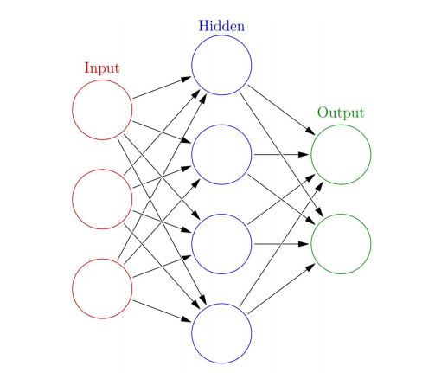
To determine the neuron's result, initially the weighted number of all the input data are calculated, which is then multiplied by the quantities of the relations between the inputs and the neuron. To this number, bias expression is added. The activation is a term used to describe the weighted number. To generate the result, the weighted

Figure 3.2: Artificial Neural Network (Zou et al., 2008)
average is transmitted via a (usually nonlinear) activation process. Data sources, such as images and vectors, are the first inputs. The final outputs, like recognizing an item in an image complete the mission (Zou et al., 2008).
Relations and Values: The system is made up of links, which each serves as an input to another neuron by passing the result from one node. Each relation is given a value that indicates its relative significance. Various input and output links are possible for a single neuron (Abbod et al., 2007).
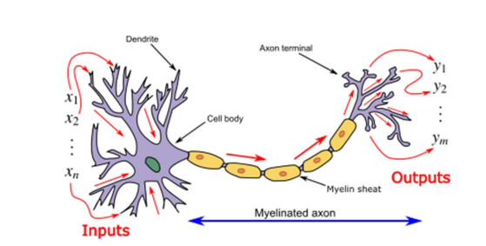
Propagation method: The propagation method calculates a neuron's input as a weighted average of its prior neurons' exits and relations. To the propagation effect, a bias phrase may be applied (Dawson & Wilby, 1998).
Figure 3.3: Transmission transfer via dendrite inputs to axon terminal outputs in a neuron and myelinated axon (Zou et al., 2008)
2.4.2 Applications of ANNs
ANNs have achieved utility in a variety of fields due to their capacity to predict and design nonlinear systems. System recognition and monitoring (car control, path prediction, control systems, natural product control), molecular chemistry, generalized gaming, sequence identification (gps systems, facial detection, pulse categorization, three - dimensional reconstruction, entity identification and much more), pattern recognition (gesture, voice, handwriting and typed characters, and much more) are some of the implementation fields (Mukhopadhyay, 2011). In addition, ANNs were able to identify various forms of tumors and to differentiate extremely aggressive tumor cells from less aggressive tumor types. Neural network were used to forecast base arrangements and to speed up the stability study of systems vulnerable to natural disasters (Abiodun et al., 2018).
In the geosciences, ANNs were used to construct dark models in hydrology, sea modeling and marine engineering, and geology (Abiodun et al., 2018). ANNs were used in cryptography with the aim of distinguishing among known and unknown activities. Computer science was used to recognise Android viruses recognize websites related to risk agents and identify Hyperlinks that pose a safety danger for instance (Abiodun et al., 2018). ANN devices are being researched for testing process, botnet detection, payment account theft detection, and network attack detection In physics, ANNs have indeed been suggested as a method for solving partial discrete formulas and simulating the structures of several stochastic systems (Abiodun et al., 2018).
In neural science ANNs have looked at the brief activities of young cells, how neural structure processes are derived from relationship among human neurons, and how actions can be derived from conceptual neural structures that form full components. From the specific neuron to the network level, researchers looked at the long- and short-term cognition of neural networks, as well as their relationship to cognition and training (Abiodun et al., 2018).

CHAPTER THREE
SYSTEM ANALYSIS
3. 0 INTRODUCTION.
This section of the project deliberates on the source of information about the current system and maintenance.
3.1 RESEARCH METHODOLOGY
In this section, a brief review of the machine learning techniques that is used in this research is introduced. Agile software development methodology is the methodology that will be used for the development of the application software components. Documentation, requirements documents and design documents, is also key parts of the methodology as well as the source code.
3.2 RESEARCH DESIGN
The design used for the study was a survey method which involved administering copies of a questionnaire to the respondents and retrieving same after completion.
3.2.1 Instrument for Data Collection
The main instrument used for the investigation was a questionnaire known as “Admission Policy and Effect on Higher Institution Education Quality” (APEHIEQ) designed by the researcher. The instrument considered the influence of the following admission criteria on the prediction of student admission: age, trials, jamb score, post jamb score etc. The APEHIEQ was designed with options for everyone filling the questionnaire to choose as applied to them.
    - ANALYSIS OF CASE STUDY
In this research, a model is proposed to predict the admission of students in an academic organization, Lagos state polytechnic using Computer science precisely as case study. The algorithm employed is a machine learning technique. Further, the importance of several different attributes, or "features" is considered, in order to determine which of these are correlated with student prediction. Finally, the results of an experiment follow, showcasing the power of machine learning in the application.

3.3 DATASET AND SYSTEM ARCHITECTURE
3.3.1 Dataset and Data Sources.
The data set is collected by preparing a questionnaire which is to be filled by students of the school who already got admitted, those who have applied but not admitted and those who are about to apply. This is to get various data points in other to gather enough fact for admission requirements from individuals. The questions in the questionnaire are prepared using google forms. A link was shared among people who are related to the subject of the problem to be solved. Below is the compilation of the questions:
How many times did you apply before you were admitted or still denied admission?
- What was your jamb score when you got admission or was denied admission?
- What was your post jamb score when you got admission or was denied admission?
- At least how many credit did you have in WAEC or NECO when you got admission or was denied admission?
- how many sittings did you used to apply for admission when it was successful or when it was denied?
- What was your age range when you got admission or when you were denied admission?
- Which department did you applied to when your admission was successful or when denied admission.
The data is collected and then downloaded from the google form platform in ms excel format and this is then analyzed to further understand the content of the input data before use.
3.3.2 Data Analysis
Clustering Techniques such as K-Means Clustering Algorithm was applied to group the data. Clustering is used for classification of the required student’s data and the acts performed are aligned into the meaningful division of groups based on previous data. The set of data items from the clustering process is then trained and tested by optimizing the error. Association rule is then used to inspect the association linking the subgroups. This process is then applied to find out the student characteristics that align the individual characteristics. The Association Rule provides the number of occurrences that it predicts correctly. The general output is observed comparing the difference with the clustering output to make the prediction more correctly. The processed data is chosen through selective sampling process and the classification rules are deduced from the training set.
  - DATA EXPLORATION WITH WEKA
WEKA, formally called Waikato Environment for Knowledge Learning, is a computer program that was developed at the University of Waikato in New Zealand for the purpose of identifying information from raw data gathered from different domains. WEKA supports many different standard data mining tasks such as data pre-processing, classification, clustering, regression, visualization and feature selection. The basic premise of the application is to utilize a computer application that can be trained to perform machine learning capabilities and derive useful information in the form of trends and patterns.
WEKA is an open source application that is freely available under the GNU general public license agreement. Originally written in C the WEKA application has been completely rewritten in Java and is compatible with almost every computing platform. It is user friendly with a graphical interface that allows for quick set up and operation. WEKA operates on the predication that the user data is available as a flat file or relation, this means that each data object is described by a fixed number of attributes that usually are of a specific type, normal alpha-numeric or numeric values. The WEKA application allows novice users a tool to identify hidden information from database and file systems with simple to use options and visual interfaces.
3.3.1. Building Classifier
Classifiers in WEKA are the models for predicting nominal or numeric quantities. The learning schemes available in WEKA include decision trees and lists, instance-based classifiers, support vector machines, multi-layer perceptrons, logistic regression, and bayes’ nets. “Meta”classifiers include bagging, boosting, stacking, error-correcting output codes, and locally weighted learning. Once the data set has been successfully loaded, all the tabs are made available. Click on the ‘Classify’ tab. ‘Classify’ window comes up on the screen. Now we can start analyzing the data using the provided algorithms.
3.2 Setting Test Options:
Before you run the classification algorithm, you need to set test options. Set test options in the ‘Test options’ box. The test options that available are:
- Use training set. Evaluates the classifier on how well it predicts the class of the instances it was trained on.
- Supplied test set. Evaluates the classifier on how well it predicts the class of a set of instances loaded from a file. Clicking on the ‘Set…’ button brings up a dialog allowing you to choose the file to test on.
- Cross-validation. Evaluates the classifier by cross-validation, using the number of folds that are entered in the ‘Folds’ text field.
4. Percentage split. Evaluates the classifier on how well it predicts a certain percentage of the data, which is held out for testing. The amount of data held out depends on the value entered in the ‘%’ field. In the ‘Classifier evaluation options’ make sure that the following options are checked
- Output model. The output is the classification model on the full training set, so that it can be viewed, visualized, etc.
- Output per-class stats. The precision/recall and true/false statistics for each class output.
- Output confusion matrix. The confusion matrix of the classifier’s predictions is included in the output.
- Store predictions for visualization. The classifier’s predictions are remembered so that they can be visualized.
- Set ‘Random seed for Xval / % Split’ to 1. This specifies the random seed used when randomizing the data before it is divided up for evaluation purposes.
When training set is complete, the ‘Classifier’ output area on the right panel of ‘Classify’ window is filled with text describing the results of training and testing. A new entry appears in the ‘Result list’ box on the left panel of ‘Classify’ window.
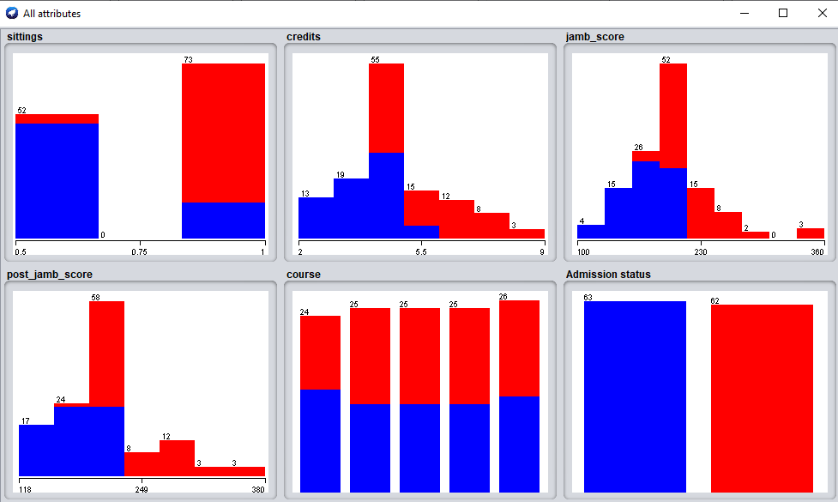
fig 3.1 data visualization from WEKA
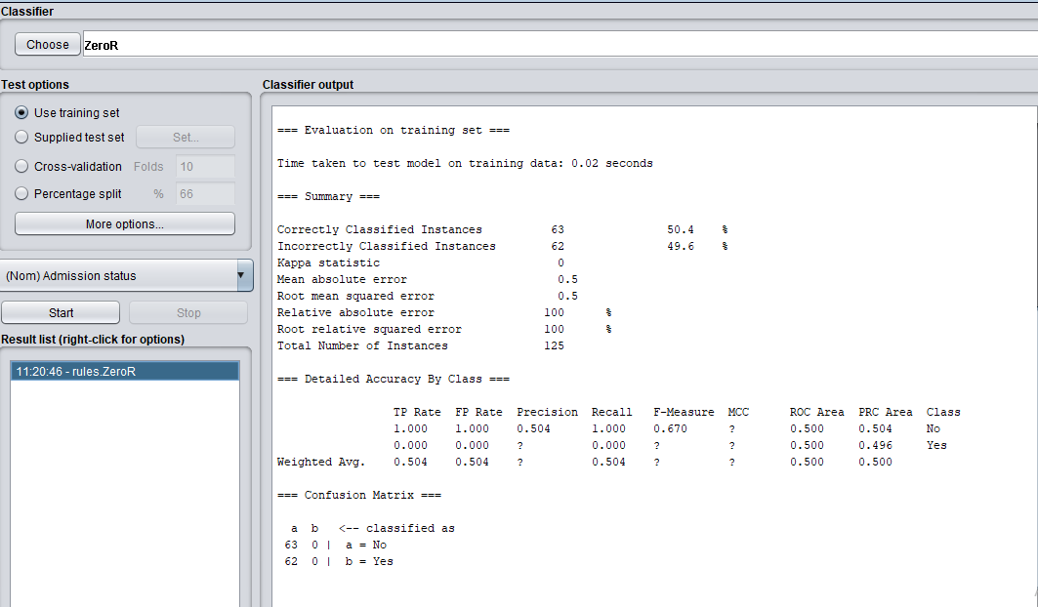
Fig 3.2 classification using WEKA
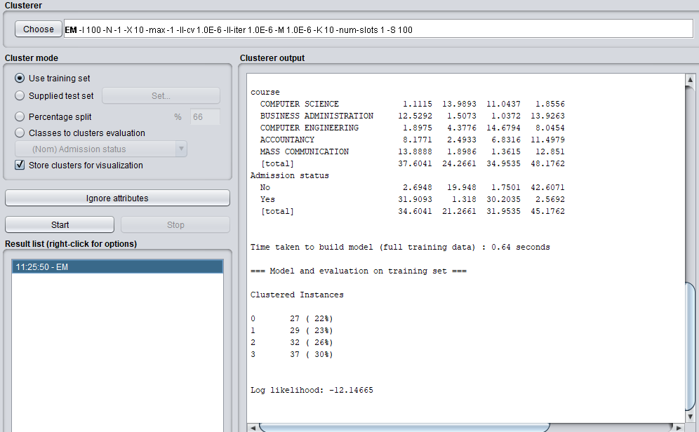
Fig 3.3 Clustering using WEKA
3.5 ALGORITHMS
The following learning algorithms are used in conjunction with the proposed methodology to evaluate the performance of fake news detection classifiers.
3.5.1. Logistic Regression
As I classify text on the basis of a wide feature set, with a binary output (true/false or true article/fake article), a logistic regression (LR) model is used, since it provides the intuitive equation to classify problems into binary or multiple classes. We performed hyper-parameters tuning to get the best result for all individual datasets, while multiple parameters are tested before acquiring the maximum accuracies from LR model. Logistic regression uses a sigmoid function to transform the output to a probability value; the objective is to minimize the cost function to achieve an optimal probability.
3.5.2. Support Vector Machine
Support Vector Machines (SVMs) is another popular machine learning method that is also applied in this study. SVMs (Cortes & Vapnik, 1995) are monitored or supervised learning frameworks that process data for labeling and regression modeling in machine learning. SVMs were developed at AT&T Bell Laboratories by Vladimir Vapnik and collaborators (Boser et al., 1992, Guyon et al., 1993, Vapnik et al., 1997) and are dependent on mathematical training models or VC theory suggested by Vapnik (1982, 1995) and Chervonenkis (1974). An SVM simulation implementation creates a prototype that applies current samples to one of two classes allowing it a non-probabilistic binary linear classification model, given a collection of learning collection each labeled as corresponding to one of two subgroups. SVM transfers learning instances to places in space in order to widen the distance among the two groups as much as possible. New instances are then traced into the same space and classified according to which side of the distance they drop on (Cortes & Vapnik, 1995). SVMs could achieve non-linear grouping as well as linear grouping by effectively translating their sources into high dimensional attribute spaces which is known as the kernel trick (Cortes & Vapnik, 1995). If information is unlabeled, supervised learning is impossible, so an unsupervised learning method is needed wherein the data is clustered naturally into classes and additional information is mapped to these classes. The support-vector classification technique was established by Hava Siegelmann and Vladimir Vapnik to classify unlabeled data using support vector statistics improved in the support vector machines method. It is among the most commonly used grouping techniques in industrial implementations (Ben-Hur, 2008). A support-vector machine, in more conceptual terms creates a decision boundary or set of hyperplanes in a high- or infinite-dimensional space that can be used for grouping, regression, or other purposes such as outlier detecting (Hastie et al., 2009). Conceptually, the hyperplane with the greatest gap to the closest training position of any category achieves a strong isolation because the greater the margin, the smaller the classifier's overfitting failure (Hastie et al., 2009).
3.5.2.1 APPLICATION OF SVM
SVMs have a wide range of implementations in a variety of fields. The following are some of the implementation areas. In traditional analytics environments, SVMs will greatly minimize the requirement for classified training examples, making them useful in document and hyperlinks classification. With the help vector machines are used in several basic textual parsing approaches (Pradhan et al., 2004).
SVMs may also be used to achieve image categorization tasks. After only 3 to 4 cycles of validity reviews, SVMs accomplish substantially better query precision than conventional request optimization systems, according to research findings (Bannay & Guillaume, 2014). This is also valid for image clustering frameworks, especially those which use a customized form of SVM that employs Vapnik's favored method (Bannay & Guillaume, 2014). Satellite, information such as SAR info is classified through monitored SVM (Maity, 2016). SVM can be used to identify typed letters. In biomedical and other studies, the SVM method has been commonly used as well. They have been utilized to categorize proteins, with up to 90% of the substances correctly categorized. SVM weights-based substring have been proposed as a method for SVM system analysis (Pradhan et al., 2004). In the past, support-vector system masses were also used to understand SVM versions (Statnikov et al., 2005). A comparatively recent field of study in the biomedical fields is posthoc analysis of support-vector system models in order to classify features used by the model to make observations.
3.5.4. K-Nearest Neighbors (KNN)
KNN is an unsupervised machine learning model where a dependent variable is not required to predict the outcome on a specific data. We provide enough training data to the model and let it decide to which particular neighborhood a data point belongs. KNN model estimates the distance of a new data point to its nearest neighbors, and the value of K estimates the majority of its neighbors’ votes; if the value of K is 1, then the new data point is assigned to a class which has the nearest distance.
3.5.5. Ensemble Learners
We proposed using existing ensemble techniques along with textual characteristics as feature input to improve the overall accuracy for the purpose of classification between a truthful and a false article. Ensemble learners tend to have higher accuracies, as more than one model is trained using a particular technique to reduce the overall error rate and improve the performance of the model. The intuition behind the ensemble modeling is synonymous to the one we are already used to in our daily life such as requesting opinions of multiple experts before taking a particular decision in order to minimize the chance of a bad decision or an undesirable outcome. For example, a classification algorithm can be trained on a particular dataset with a unique set of parameters that can produce a decision boundary which fits the data to some extent. The outcome of that particular algorithm depends not only on the parameters that were provided to train the model, but also on the type of training data. If the training data contains less variance or uniform data, then the model might overfit and produce biased results over unseen data. Therefore, approaches like cross validation are used to minimize the risk of overfitting. A number of models can be trained on different set of parameters to create multiple decision boundaries on randomly chosen data points as training data. Hence, using ensemble learning techniques, these problems can be addressed and mitigated by training multiple algorithms, and their results can be combined for near optimum outcome. One such technique is using voting classifiers where the final classification depends on the major votes provided by all algorithms.
3.6. RECOMMENDATION SYSTEM TYPES
During the last few decades, with the rise of Youtube, Amazon, Netflix and many other such web services, recommender systems have taken more and more place in our lives. From e-commerce (suggest to buyers articles that could interest them) to online advertisement (suggest to users the right contents, matching their preferences), recommender systems are today unavoidable in our daily online journeys.
In a very general way, recommender systems are algorithms aimed at suggesting relevant items to users (items being movies to watch, text to read, products to buy or anything else depending on industries). Recommender systems are really critical in some industries as they can generate a huge amount of income when they are efficient or also be a way to stand out significantly from competitors. As a proof of the importance of recommender systems, we can mention that, a few years ago, Netflix organised a challenges (the “Netflix prize”) where the goal was to produce a recommender system that performs better than its own algorithm with a prize of 1 million dollars to win. In this article, we will go through different paradigms of recommender systems. For each of them, we will present how they work, describe their theoretical basis and discuss their strengths and weaknesses.
3.6.1 Popularity-Based Recommendation System
It is a type of recommendation system which works on the principle of popularity and or anything which is in trend. These systems check about the product or movie which are in trend or are most popular among the users and directly recommend those.
For example, if a product is often purchased by most people then the system will get to know that that product is most popular so for every new user who just signed it, the system will recommend that product to that user also and chances becomes high that the new user will also purchase that.
3.6.2 Classification Model: Classification can be performed on structured or unstructured data. Classification is a technique where we categorize data into a given number of classes. The main goal of a classification problem is to identify the category/class to which a new data will fall under. The model that uses features of both products as well as users to predict whether a user will like a product or not.
3.6.3 Content-Based Recommendation System
It is another type of recommendation system which works on the principle of similar content. If a user is watching a movie, then the system will check about other movies of similar content or the same genre of the movie the user is watching. There are various fundamentals attributes that are used to compute the similarity while checking about similar content. In contrast to collaborative filtering, content-based approaches will use additional information about the user and / or items to make predictions. That’s why when you sign up for many online websites and services, they ask you to (optionally) give your date of birth, gender, and ethnicity! It’s just more data for their system to make better predictions.
Thus, content-based methods are more similar to classical machine learning, in the sense that we will build features based on user and item data and use that to help us make predictions. Our system input is then the features of the user and the features of the item. Our system output is the prediction of whether or not the user would like or dislike the item. Typically, each item with its features is mapped to a low-dimensional embedding space. Then, using a similarity measure, one can identify items in the same neighborhood on the embedding space and suggest those items to the users. The similarity function can be simple functions such as the dot-product, or the Euclidean distance, or more complex ones.
3.6.3.1 Deep Content-based recommendation
That’s why Deep Learning can be used for standard content-based recommendations. By using a neural network, we can construct high-quality low-dimensional embeddings and recommend items close in the embedding space. Spotify has used this approach with great success: they used a CNN to transform audio (in the form of mel spectrograms) into compact representations, and then suggest to the user similar songs with what they have already listened to.
This idea can be extended into content embeddings (Content2Vec) where we can represent all kinds of items in an embedding space; whether the items are images, text, songs etc. Then we use a pair-wise item similarity metric to generate recommendations. Transfer learning can obviously play a major role in this approach.
The content embeddings can be used either in a content-based strategy or as extra information on CF techniques, as we will see.
3.6.4. Collaborative Filtering
Collaborative filtering methods for recommender systems are methods that are solely based on the past interactions between users and the target items. Thus, the input to a collaborative filtering system will be all historical data of user interactions with target items. This data is typically stored in a matrix where the rows are the users, and the columns are the items. The core idea behind such systems is that the historical data of the users should be enough to make a prediction. I.e we don’t need anything more than that historical data, no extra push from the user, no presently trending information, etc.
Beyond this, collaborative filtering methods are further divided into two sub-groups: memory-based and model-based methods.
Memory-based methods are the most simplistic as they use no model whatsoever. They assume that predictions can be made on pure “memory” of past data and usually just employ a simple distance-measurement approach, like nearest neighbour.
Model-based approaches, on the other hand, always assume some kind of underlying model and basically try to make sure that whatever predictions come out will fit the model well.
As an example, let’s say we have a matrix of users-to-preferred lunch item where all of the users are Americans who love cheeseburgers (they are phenomenal). A memory-based method will only look at what the user has eaten over the past month, without considering that mini-fact of them being cheeseburger loving Americans. A model-based method, on the other hand, will ensure that the predictions always lean a bit more towards being a cheeseburger, since the underlying model assumption is that most people in the dataset should love cheeseburgers!
It is considered to be one of the very smart recommender systems that work on the similarity between different users and also items that are widely used as an e-commerce website and also online movie websites. It checks about the taste of similar users and does recommendations. The similarity is not restricted to the taste of the user moreover there can be consideration of similarity between different items also. The system will give more efficient recommendations if we have a large volume of information about users and items.
3.6.5 Hybrid Recommender
Hybrid recommender is a recommender that leverages both content and collaborative data for suggestions. In a system, first the content recommender takes place as no user data is present, then after using the system the user preferences with similar users are established.
For example, Netflix deploys hybrid recommender on a large scale. When a new user subscribes to their service they are required to rate content already seen or rate particular genres. Once the user begins using the service, collaborative filtering is used and similar content is suggested to the customer.
3.7 SIMILARITY MEASURES
Similarity is measured using the distance metric. Nearest points are the most similar and farthest points are the least relevant. The similarity is subjective and is highly dependent on the domain and application. For example, two movies are similar because of genre or length or cast. Care should be taken when calculating distance across dimensions/features that are unrelated. The relative values of each element must be normalized, or one feature could end up dominating the distance calculation.
3.7.1 Minkowski Distance: When the dimension of a data point is numeric, the general form is called the Minkowski distance. It is a generic distance metric where Manhattan(r=1) or Euclidean(r=2) distance measures are generalizations of it.
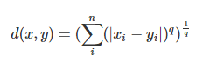
Minkowski distance
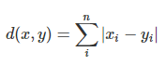
3.7.2 Manhattan Distance: The distance between two points measured along axes at right angles. It is also called rectilinear distance, L1-distance/L1-norm, Minkowski’s L1- distance, city block distance and taxi cab distance.
Manhattan Distance
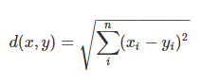
3.7.3 Euclidean Distance: The square root of the sum of squares of the difference between the coordinates and is given by Pythagorean theorem. It is also called as L2 norm or ruler distance. In general, default distance is considered Euclidean distance.
Euclidean distance
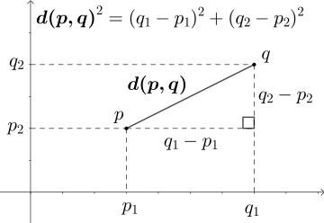
Fig 3.1 Euclidean Distance (General)
3.7.4 Cosine Similarity: Measures the cosine of the angle between two vectors. It is a judgment of orientation rather than magnitude between two vectors with respect to the origin. The cosine of 0 degrees is 1 which means the data points are similar and cosine of 90 degrees is 0 which means data points are dissimilar.
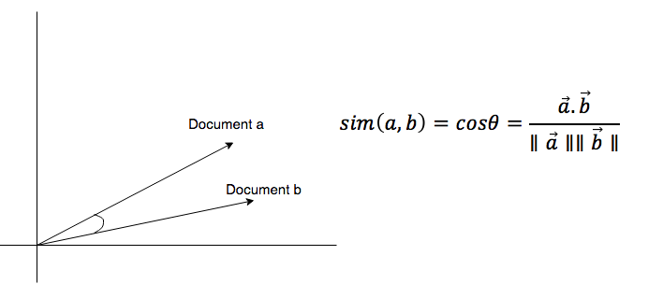
Cosine similarity is subjective to the domain and application and is not an actual distance metric. For example data points [1,2] and [100,200], are shown as similar with cosine similarity, whereas the Euclidean distance measure shows them as being far away from each other (i.e., they are dissimilar).
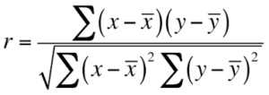
3.7.5 Pearson Coefficient: It is a measure of correlation between two random variables and ranges between [-1, 1].
Pearson Correlation Coefficient
If the value is 1, it is a positive correlation, and if -1 then there is a negative correlation among variables.
3.7.6 Jaccard Similarity: In the other similarity metrics, we discussed some ways to find the similarity between objects, where the objects are points or vectors. We use Jaccard similarity to find similarities between finite sets. It is defined as the cardinality of the intersection of sets divided by the cardinality of the union of the sample sets.
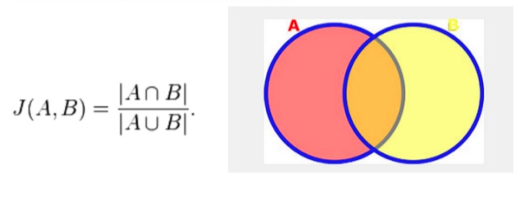
fig 3.2 Jaccard Similarity
3.7.7 Hamming Distance: All the similarities we discussed were distance measures for continuous variables. In the case of categorical variables, Hamming distance must be used.
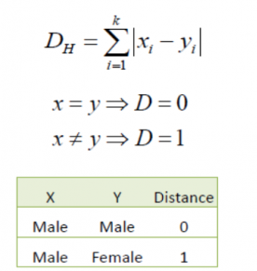
Hamming distance
If the value (x) and the value (y) are the same, the distance D will be equal to 0, otherwise D=1. If we have data that is binary (i.e., classification), one would go for Hamming distance. The lower value means high similarity and higher value means less similarity between variables. For example, the Hamming distance between 1101111 and 1001001 is 3, while the Hamming distance between ‘batman’ and ‘antman’ is 2
3.8 Program design
The programming language used in this research is Python Programming language. It is so because it is the most popular language for artificial intelligence. Libraries such as pandas, numpy, and others are responsible for data preprocessing. A model is built using machine learning algorithms using the sci kit learn library. The dataset is splitted into training, testing and validation set, and then then the training sets are used in training the model, the test set used for evaluating the model.
3.9 Design of the User Interface
The user interface is designed in other to make it possible for the end users of the program to interact with the codes. There are buttons to be clicked for some actions to take place. All these are embedded in the user interface. The user interface is designed to have a good user experience as well in other to make it easy for users to understand the how to handle widgets in a way they are used to or from their experiences with other user interfaces.
3.10 Module Specifications
The program module includes:
- The dataset import
- Clean Dataset
- Preprocess dataset
- Train Model
- Test Model
- Evaluate
- Save Model

START
IMPORT DATASET
CLEAN DATASET
PROPROCESS DATASET
TRAIN MODEL
TEST MODEL
OUTPUT
END
PREDICT ADMISSION

unsuccessful
successful
RECOMMEND

Fig 3.3 Program flow chat
3.11 JUSTIFICATION OF PROGRAMMING LANGUAGE
The programming language used in building the project for the implementation of this research is Python Programming language. In this section, some of the justifications and major reasons why python is chosen as the programming language of choice are specified.
AI projects differ from traditional software projects. The differences lie in the technology stack, the skills required for an AI-based project, and the necessity of deep research. To implement your AI aspirations, you should use a programming language that is stable, flexible, and has tools available. Python offers all of this, which is why we see lots of Python AI projects today.
From development to deployment and maintenance, Python helps developers be productive and confident about the software they’re building. Benefits that make Python the best fit for machine learning and AI-based projects include simplicity and consistency, access to great libraries and frameworks for AI and machine learning (ML), flexibility, platform independence, and a wide community. These add to the overall popularity of the language.

CHAPTER FOUR
SYSTEM DESIGN AND IMPLEMENTATION
4.1. INTRODUCTION
This chapter covers the scope and implementation of the research which is sub divided into the system and software requirements, Hardware and software specifications, results and evaluations,
4.2. IMPLEMENTATION
Python was used because it is a very reliable scripting language for machine programming and also it has large community base to ask questions when needs arises.
IDLE: is an integrated development environment for python programming language, which has been bundled with the default implementation of the language since 1.5.2b1. It is packaged as an optional part of the Python packaging with many Linux distributions. It is completely written in Python and the PyQt5 GUI toolkit.

Using WEKA, an analysis of the dataset was conducted, and the recommendation was carried out using python programming language. A machine learning model is built using the Jupyter environment in anaconda, and then exported into the spyder IDE. It is in the spyder that the model is marched with the GUI and then feed with data from the front end for a prediction. After the prediction has been made and it is negative, the system uses a recommendation algorithm which has been built to recommend at least a course to the user. All these comes out as an output as the user makes use of the software.

4.2.1 Dataset
The Data set is a collection of relatable data that can be processed and analyzed to give a useful information as needed when queried. Data can be used to do so much more such as prediction systems and recommendation system as it is being used in this project for thesame purpose. The dataset used in this project is gotten using a questionnaire. Graduated, undergraduates, and jambites were asked to fill the form in other to get enough data for processing. The dataset has 6 columns, which are; name, number of o-level credits, sittings, jamb score, post jamb score, admission status. After cleaning the data and processing it, 4 columns serves as the input and one as the output column for the prediction which is the admission status column and it reads yes/no. The recommendation algorithm uses the admission status that reads yes to for its recommendation using the kmeans algorithm.

4.3 SYSTEM REQUIREMENTS
This covers the software requirements, Hardware and People-ware requirement.
4.3.1 SOFTWARE REQUIREMENTS
Software in computer is divided into system and application software. The system software are built programs that come with the system or provided by the computer manufacturers while the application program or software are these programs that are designed to solve a particular problem. The software requirement for the proposed system is;
- Minimum of Window 8 operating system
- Python programming language.

4.3.2 Hardware requirements
Hardware
- Corei3 processor
- Speed 2.5 GHZ
- Main memory
- Hard disk capacity 500 Gb
- Monitor 14 inch VGA
- Ups (uninterrupted power supply)
- Serial port two
- Standard or enhanced keyboard
- A desk jet computer
People Requirements
i. Programmers
ii. Students

4.3.3 PROGRAM SCREENSHOT
Landing page: This is the welcome page of the software when it opens up. The user is meant to click on the “continue” button to redirect to the next page.
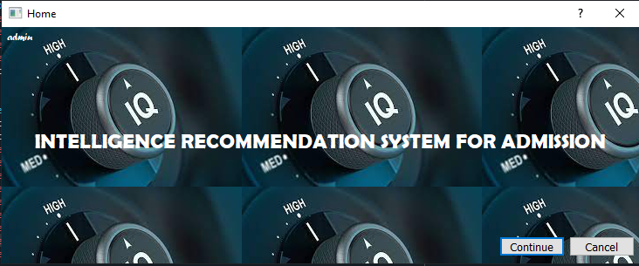
Fig 4.1 Landing Page
Landing Page: The above shot shows the first page that displays immediately the user starts the application. It has the continue button that allows the user to navigate to the main page of the application to make use of the program and a cancel button which if clicked closes the application completely. There is also an admin button that gives the admin an opportunity to view the admin dashboard.
Main Page
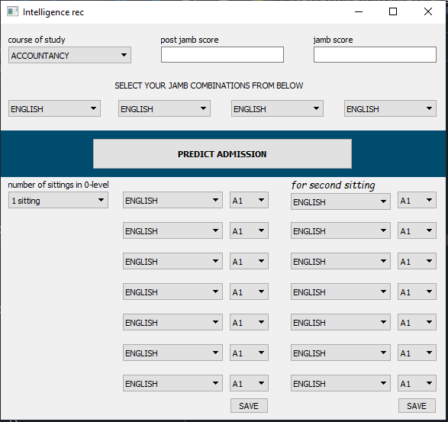

Fig 4.2 Main Page
Main Page: The main page is the page where the user supplies input to the available fields and then a result is generated based in the input supplied. The user will input their o-level grades and then click save, for 2 sittings, the user has to save for the other sitting too. The user is also expected to choose their jamb combinations. The user is meant to click the “predict admission” button to trigger the program to process the information and return an output on a message box.

Output
Fig 4.3 Output Page
Output: The above image shows the sample output that is displayed after the user clicked the button.

ADMIN PAGE
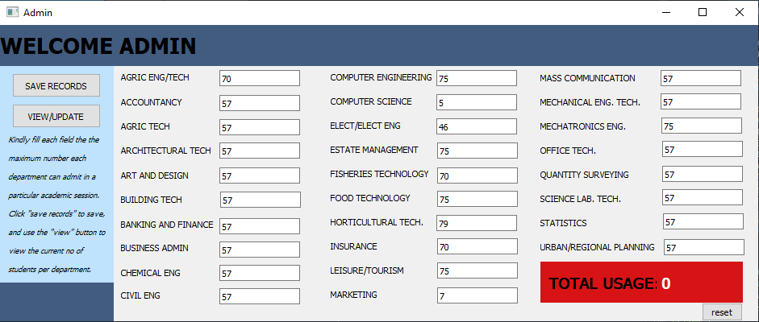
Fig 4.4 Admin Page
Admin Page: On the admin dashboard, the admin has the opportunity to enter maximum number of student that can be admitted by each department per section. Also the admin has the ability to update these records. The admin also can view number of people that has used the system for admission recommendations.
4.4 SYSTEM TESTING
Python programming language has distinct modes for developing an Artificial Intelligent system. Before the program is implemented, the user must test and run it and if bug is found in the program, the developer debug the program so that the program can run without bugs when the program is free of bugs it can then be implemented fully.
In this section various types of test (such as modular/unit testing and integrated testing) carried out to ensure that the developed software did not deviate from the design specification are discussed.

4.5 IMPLEMENTATION DETAILS
As discussed earlier in the previous chapter about the module we have in the program, I shall review them by starting the program one by one, to really see how each module is implemented.
USING THE GRAPHICAL USER INTERFACE FORMS
A very good example of a graphical user interface (GUI) form is the users data form. This serves as a link/platform between the user and the model.
4.5.1 CODING.
The total code size is about 3MB with procedural coding pattern.

4.5.2 END USER TRAINING AND MANUAL
A document has been included in the software to assist in installing the software and configuring the settings. There is a zip file to be extracted where user manual is included that bears the step by step procedure to setting up the system. There is a requirement file along, it bears all the necessary

4.5.2 PROGRAM TESTING AND DEBUGGING
Python programming language has distinct modes for developing a prediction system. Before the program is implemented, the user must test and run it and if bug are found in the program, the developer debug the program so that the program can run without bugs when the program is free of bugs it can then be implemented fully.
4.5.3 PROGRAM DOCUMENTATION
This is an important part of system development it uses the techniques and tools of system analysis and design to record and communicates the activities and result of each stay of information system development.
The hardware has all features required to best utilize the software. The software can handle the data processing assignment easily without major modification, and the language it is written in a programming language that is commonly used by Artificial intelligent system developers and user.
4.6 SYSTEM EVALUATION AND MAINTENANCE
Maintenance of the system means keeping the system running without a problem that may cause the system to breakdown. The steps outlined below can help prevent the system:
- No usage of outside source floppy disk, flash drives or CD-Rom which may contain program that can rearrange files in the system.
- No external bodies should be allowed to access the system
- Anti-virus package most be installed and updated annually.
- The system should be out of reach to unauthorized users in the organization
- Faulty material should be changed immediately.
4.7 CHANGE OVER PROCEDURE
This is the implementation process which the changes are made from the existing system to the newly designed one. There are three basic methods
- Pilot Change Over: This involves changing part of the system using parable or indirect change over procedure. These procedure is a trial system implementation in a subset of the overall operation as an office geographical area.
- Direct Change Over: This is termed immediate or crash change over using this method, the old system is discontinued and the new system is put into operation at once. For a large organization. This system is risky should there be a system failure. This approach is feasible only the timing problem becomes greater as the scale of operation increase with regard to me new system an individual can easily adapt. This system without much course to regret
- Parallel Change Over: Is a change over procedure where the old system is run in parallel with the new system and comparison made for a whole. One merit is that, there is room for proper evaluation of the new system as to ascertain errors in any of the process. This method has been formed to be operational effective despite the fact that procedure is not cost-effective.
4.8 DOCUMENTATION
Documentation is very important since it is a method of recording and communicating the activities of the system development and the outcomes of each stage in the entire process. Documentation of any system will minimize during the problem that may be encountered during modification or maintenance of the system. Documentation serves the following purpose.
- Eliminates duplicates and reducing of effort in the system development process
- It minimizes ambiguity in the procedures
- It prevents loss of key information vital to proper implementation of the system.
- It provides adequate instruction for proper use of the system.
The complexity of the system documentation will normally depend on the extent of the system being developed. For instance a system being developed for a temporary use would not required a detailed documentation as the system being developed for permanent use. Nevertheless system documentation is divided into two parts system manual and user manual.

CHAPTER FIVE
SUMMARY, RECOMMENDATION AND CONCLUSION
5.1 SUMMARY
Intelligence recommendation system for admission is an important project due to the delay students passes through before getting admission into the department of their choice. These methods are used in making students predict their chances of getting admission and also get the best department to apply to based on their level of intelligence before even applying to a particular department in the lagos state polytechnic. The educational institutions are often curious that how many students will be admitted and how best to choose their preferred set of students. In previous studies, it has been observed that many researchers have plans on the selection of appropriate algorithm for just classification and ignores the solutions of the problems which comes during data mining phases such as data high dimensional, class imbalance and classification error etc. Such types of problems reduced the accuracy of the model. Several well-known classification algorithms are applied in this domain but this project proposed a intelligence recommendation for admission based on cluster algorithm. Before that, a classifier such as logistic regression was used for a prediction task, which predicts if the student will be admitted into the department or not. ms. This study proves the importance of data preprocessing and algorithms fine tuning tasks to resolve the data quality issues.
5.2 RECOMMENDATION
This project is therefore recommended to be used in schools, Individuals and other organizations to manage their users queries, information management system and carry out system predictions and forecasts etc. Scholars can as well find this material resourceful to further on the research on student’s admission or general prediction system. The research work can also be furthered to improve the way Artificial intelligent is used among organizations, brands and other companies.

5.3 CONCLUSION
The technique that have been utilized in this research, machine learning, the data set processing. Both techniques have shown an improvement in the accuracy of predictions, thereby yielding positive results. Use of recently introduced machine learning techniques in the prediction of stocks have yielded promising results and thereby marked the use of them in predicting student’s admission and also recommending other departments for those who are not qualified for the admission. It has led to the conclusion that it is possible to predict a student’s admission into specified departments and also recommend for them with more accuracy and efficiency using machine learning techniques. In the future, the prediction and recommendation system can be further improved by utilizing a much bigger data set.
5.4 CONTRIBUTION TO KNOWLEDGE
The system will contribute immensely in the academic settings. Lagos state polytechnic will benefit from this research as the applicants can easily get recommendations for courses they can apply for based on their level of intelligence.

REFERENCES
Alaa K.H. (2016). “Selection of Best Decision Tree algorithm for prediction and classification of student Action” American International Journal of Research in Science, Technology, Engineering & Mathematics, vol 1, pp. 2
Annam MallikharjunaRoa et al (2018). College Admission Predictor, published in Journal of Network Communications and Emerging Technologies (JNCET), Vol. 8, Issue 4.
Austin Waters and RistoMiikkulainen, (2013) GRADE: Machine Learning Support for Graduate Admissions, In Proceedings of the 25th Conference on Innovative Applications of Artificial Intelligence, Association for the Advancement of Artificial Intelligence.
Carlos M.C. (2013). “Predicting student failure at school using genetic programming.” ApplIntell, vol. 38, pp.315–330.
Dech Thammasiri, DursunDelen, PhayungMeesad andNihatKasap. (2014). “A critical assessment of imbalanced class distribution problem: The case of predicting freshmen student attrition.” Expert Systems with Applications, 41, pp.321–330. https://doi.org/10.1016/ j.eswa.2013.07.046.
Farshid M.N. (2016). “Models for early prediction at risk students in a course using standard based grading.Computers & Education,” 103, pp. 1-15.
HeenaSabnani, Mayur More, Prashant Kudale, SurekhaJanrao, (2018) “Prediction of Student Enrolment Using Data Mining Techniques”, Published in International Research Journal of Engineering and Technology Vol. 05, Issue 04.
HimanshuSonawane, “Student Admission Predictor”, (2018) MSc Research Project Data Analytics, National College of Ireland Project Submission Sheet –School of Computing.
https://files.eric.ed.gov/fulltext/EJ788429.pdf

Jared Cirelli, Andrea M. Konkol, Faisal Aqlan, (2018) “Predictive Analytics Models for Student Admission and Enrolment, in proceedings of the International Conference on Industrial Engineering and Operations Management Washington DC, USA, September 27-29.
KanadpriyaBasu, TreenaBasu, Ron Buckmire, and NishuLal, (2019) “Predictive Models of Student College Commitment Decisions Using Machine Learning” ,vol. 4, issue 2, pp. 1-18.
Mane, R.V., Ghorpade, V.R., (2016) “Predicting student admission decisions by association rule mining with pattern growth approach” In: 2016 International Conference on Electrical, Electronics, Communication, Computer and Optimization Techniques pg. 202–207.
SreckoNatek M.Z (2014). Student data mining solution–knowledge management system related to higher education institutions. Expert Systems with Applications, 41, pp.6400–6407.
- Hut, M. Gardener, D. Kamentz, A. Duckworth, and S. D’Mello, (2018) “Prospectively Predicting 4-Year College Graduation from Student Application”, In International Conference on Learning Analytics and Knowledge, March 7–9, Australia, pp. 412–417.
Thomas Lux et al. (2016), “Applications of Supervised Learning Techniques on Undergraduate Admissions Data”, CF '16: Proceedings of the ACM International Conference on Computing Frontiers, May 16-19, Pages 412–417.

APPENDIX
from PyQt5 import QtCore, QtGui, QtWidgets
from intelligence import *
class Ui_Std_front(object):
def cancel(self):
Std_front.close()
def cont(self):
self.window = QtWidgets.QMainWindow()
self.ui = Ui_admision()
self.ui.setupUi(self.window)
self.window.show()
Std_front.hide()

def setupUi(self, Std_front):
Std_front.setObjectName("Std_front")
Std_front.resize(731, 271)
self.frame = QtWidgets.QFrame(Std_front)
self.frame.setGeometry(QtCore.QRect(0, 0, 731, 271))
self.frame.setFrameShape(QtWidgets.QFrame.StyledPanel)
self.frame.setFrameShadow(QtWidgets.QFrame.Raised)
self.frame.setObjectName("frame")
self.label = QtWidgets.QLabel(self.frame)
self.label.setGeometry(QtCore.QRect(0, 0, 731, 271))
self.label.setObjectName("label")
self.label.setStyleSheet("background-image: url(myimg/intelimg3.jpg)")

self.label_2 = QtWidgets.QLabel(self.frame)
self.label_2.setGeometry(QtCore.QRect(0, 90, 731, 81))
self.label_2.setStyleSheet("font: 50 18pt \"Berlin Sans FB Demi\";\n"
"color: rgb(255, 255, 255);")
self.label_2.setAlignment(QtCore.Qt.AlignCenter)
self.label_2.setObjectName("label_2")

self.pushButton = QtWidgets.QPushButton(self.frame)
self.pushButton.setGeometry(QtCore.QRect(570, 240, 75, 23))
self.pushButton.setStyleSheet("\n"
"font: 75 10pt \"MS Shell Dlg 2\";")
self.pushButton.setObjectName("pushButton")
self.pushButton.clicked.connect(self.cont)

self.pushButton_2 = QtWidgets.QPushButton(self.frame)
self.pushButton_2.setGeometry(QtCore.QRect(650, 240, 75, 23))
self.pushButton_2.setStyleSheet("\n"
"font: 75 10pt \"MS Shell Dlg 2\";")
self.pushButton_2.setObjectName("pushButton_2")
self.pushButton_2.clicked.connect(self.cancel)

self.retranslateUi(Std_front)
QtCore.QMetaObject.connectSlotsByName(Std_front)

def retranslateUi(self, Std_front):
_translate = QtCore.QCoreApplication.translate
Std_front.setWindowTitle(_translate("Std_front", "Home"))
self.label.setText(_translate("Std_front", ""))
self.label_2.setText(_translate("Std_front", "INTELLIGENCE RECOMMENDATION SYSTEM FOR ADMISSION"))
self.pushButton.setText(_translate("Std_front", "Continue"))
self.pushButton_2.setText(_translate("Std_front", "Cancel"))
if __name__ == "__main__":
import sys
app = QtWidgets.QApplication(sys.argv)
Std_front = QtWidgets.QDialog()
ui = Ui_Std_front()
ui.setupUi(Std_front)
Std_front.show()
sys.exit(app.exec_())
table = pd.DataFrame([[sitting, credit , jamb, postjamb, dept]], columns = ['sittings', 'credits', 'jamb_score', 'post_jamb_score','course'])
table['sittings'] = table['sittings'].apply(self.sit)
lb = LabelEncoder()
new_table['course'] = lb.fit_transform(new_table['course'])

sc = StandardScaler()
Xsc = sc.fit_transform(new_table)

X_sc = pd.DataFrame(Xsc, columns = [['sittings', 'credits', 'jamb_score', 'post_jamb_score', 'course']]
filename = 'intellect.sav'
loaded_model = pickle.load(open(filename, 'rb'))
ypred = loaded_model.predict(X_sc)
if ypred[-1] == 1:
self.mess("intellect", "You will get admission into the department!")
elif ypred[-1] == 0:
course_list = self.recommend()
if dept in course_list:
course_list.remove(dept)
courses = ' ,'.join(course_list)
result = "You might not get an admission into the department of your choice\n \
Kindly check our recommendation below: \n\n\n{}".format(courses)
self.mess("intellect", result)

def setupUi(self, admision):
admision.setObjectName("admision")
admision.resize(542, 148)
self.bglabel = QtWidgets.QLabel(admision)
self.bglabel.setGeometry(QtCore.QRect(0, 0, 721, 141))
self.bglabel.setText("")
self.bglabel.setObjectName("bglabel")
self.btn_label = QtWidgets.QLabel(admision)
self.btn_label.setGeometry(QtCore.QRect(0, 90, 721, 81))
self.btn_label.setObjectName("btn_label")
self.btn_pred = QtWidgets.QPushButton(admision)
self.btn_pred.setGeometry(QtCore.QRect(370, 100, 161, 41))
font = QtGui.QFont()
font.setBold(True)
font.setWeight(75)
self.btn_pred.setFont(font)
self.btn_pred.setObjectName("btn_pred")
self.btn_pred.clicked.connect(self.predictor)

self.cmb_dept = QtWidgets.QComboBox(admision)
self.cmb_dept.setGeometry(QtCore.QRect(10, 30, 161, 22))
self.cmb_dept.setObjectName("cmb_dept")
self.cmb_dept.addItem("ACCOUNTANCY")
self.cmb_dept.addItem("AGRIC ENG/TECH")
self.cmb_dept.addItem("AGRIC TECH")
self.cmb_dept.addItem("ARCHITECTURAL TECH")
self.cmb_dept.addItem("ARTS AND DESIGN")
self.cmb_dept.addItem("BANKING AND FINANCE")
self.cmb_dept.addItem("BUILDING TECH")
self.cmb_dept.addItem("BUSINESS ADMIN")
self.cmb_dept.addItem("CHEMICAL ENG.")
self.cmb_dept.addItem("CIVIL ENG.")
self.cmb_dept.addItem("COMPUTER ENGINEERING")
self.cmb_dept.addItem("COMPUTER SCIENCE")
self.cmb_dept.addItem("ELECT/ELECT ENG.")
self.cmb_dept.addItem("ESTATE MANAGEMENT")
self.cmb_dept.addItem("FISHERIES TECHNOLOGY")
self.cmb_dept.addItem("FOOD TECHNOLOGY")
self.cmb_dept.addItem("HORTICULTURAL TECH")
self.cmb_dept.addItem("INSURANCE")
self.cmb_dept.addItem("LEISURE/TOURISM")
self.cmb_dept.addItem("MARKETING")
self.cmb_dept.addItem("MASS COMMUNICATION")
self.cmb_dept.addItem("MECHANICAL ENG TECH")
self.cmb_dept.addItem("MECHATRONICS ENG")
self.cmb_dept.addItem("OFFICE TECH")
self.cmb_dept.addItem("QUANTITY SURVEYING")
self.cmb_dept.addItem("SCIENCE LAB. TECH")
self.cmb_dept.addItem("STATISTICS")
self.cmb_dept.addItem("URBAN/REGIONAL PLANNING")

self.cmb_olevel = QtWidgets.QComboBox(admision)
self.cmb_olevel.setGeometry(QtCore.QRect(10, 110, 161, 22))
self.cmb_olevel.setObjectName("cmb_olevel")
self.cmb_olevel.addItem("1 sitting")
self.cmb_olevel.addItem("2 sittings")

self.label = QtWidgets.QLabel(admision)
self.label.setGeometry(QtCore.QRect(10, 90, 141, 21))
self.label.setObjectName("label")

self.label_5 = QtWidgets.QLabel(admision)
self.label_5.setGeometry(QtCore.QRect(190, 10, 141, 21))
self.label_5.setObjectName("label_5")

self.label_6 = QtWidgets.QLabel(admision)
self.label_6.setGeometry(QtCore.QRect(10, 10, 141, 21))
self.label_6.setObjectName("label_6")

self.label_7 = QtWidgets.QLabel(admision)
self.label_7.setGeometry(QtCore.QRect(370, 10, 141, 21))
self.label_7.setObjectName("label_7")

self.label_8 = QtWidgets.QLabel(admision)
self.label_8.setGeometry(QtCore.QRect(190, 90, 141, 21))
self.label_8.setObjectName("label_8")

self.txt_jamb = QtWidgets.QLineEdit(admision)
self.txt_jamb.setGeometry(QtCore.QRect(190, 30, 161, 21))
self.txt_jamb.setObjectName("txt_jamb")

self.txt_credits = QtWidgets.QLineEdit(admision)
self.txt_credits.setGeometry(QtCore.QRect(190, 110, 161, 21))
self.txt_credits.setObjectName("txt_credits")

self.txt_post = QtWidgets.QLineEdit(admision)
self.txt_post.setGeometry(QtCore.QRect(370, 30, 161, 21))
self.txt_post.setObjectName("txt_post")

self.retranslateUi(admision)
QtCore.QMetaObject.connectSlotsByName(admision)

def retranslateUi(self, admision):
_translate = QtCore.QCoreApplication.translate
admision.setWindowTitle(_translate("admision", "Intelligence rec"))
self.btn_label.setText(_translate("admision", ""))
self.btn_pred.setText(_translate("admision", "PREDICT ADMISSION"))
self.label.setText(_translate("admision", "number of sittings in 0-level"))
self.label_5.setText(_translate("admision", "jamb score"))
self.label_6.setText(_translate("admision", "course of study"))
self.label_7.setText(_translate("admision", "post jamb score"))
self.label_8.setText(_translate("admision", "number of 0-level credits"))
if __name__ == "__main__":
import sys
app = QtWidgets.QApplication(sys.argv)
admision = QtWidgets.QDialog()
ui = Ui_admision()
ui.setupUi(admision)
admision.show()
sys.exit(app.exec_())

